My First Rmd

Jake Rozran

2022-01-18

Table of Contents

# Update the YAML Header

Go into the YAML Header above and:

1. Add your name as the author
2. Make the title “My first Rmd”
3. Add today’s date or (optionally) add in the r command to dynamically add today’s date
4. (Optionally) add a table of contents

# Our First Code Chunk

By now, we should have installed tidyverse and mdsr. Load those packages here, in the first chunk. That is best practice.

library(tidyverse)

## ── Attaching packages ─────────────────────────────────────── tidyverse 1.3.1 ──

## ✓ ggplot2 3.3.5 ✓ purrr 0.3.4  
## ✓ tibble 3.1.4 ✓ dplyr 1.0.7  
## ✓ tidyr 1.1.3 ✓ stringr 1.4.0  
## ✓ readr 2.0.1 ✓ forcats 0.5.1

## ── Conflicts ────────────────────────────────────────── tidyverse_conflicts() ──  
## x dplyr::filter() masks stats::filter()  
## x dplyr::lag() masks stats::lag()

library(mdsr)

# The Next Chunk

Click the green arrow on the top right of the chunk below. What happens? (Write your response in the area below the chunk.)

summary(cars)

## speed dist   
## Min. : 4.0 Min. : 2.00   
## 1st Qu.:12.0 1st Qu.: 26.00   
## Median :15.0 Median : 36.00   
## Mean :15.4 Mean : 42.98   
## 3rd Qu.:19.0 3rd Qu.: 56.00   
## Max. :25.0 Max. :120.00

It tells us a summary of our speed and distance of the cars variable.

# Our First Plot

Click the green arrow on the top right of the chunk below. What happens? (Write your response in the area below the chunk.)

plot(pressure)

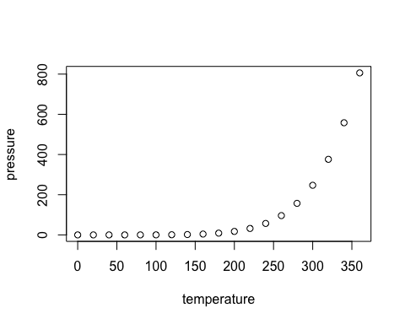

# Creating our First Chunk

Create an r code chunk below. Name it something meaningful. Then add code in the chunk that subtracts 10 from 5.

5 - 10

## [1] -5

# Create Another Chunk

Create an r code chunk below. Name it something meaningful. Also, this time add an option so that the code is not shown in the knitted output (only the output). Inside the chunk, put the following code to plot a histogram: hist(runif(1000)).

hist(runif(1000))

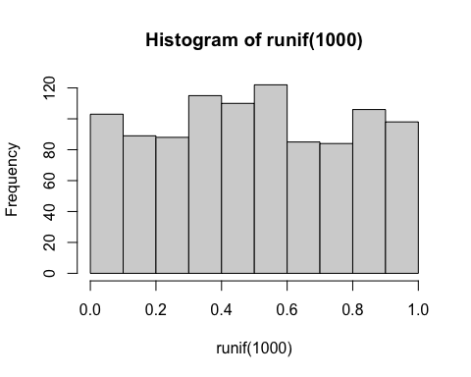

# Running Code In-Line

Below this text, create some in-line code that evaluates 100 divided by 39.

Here is some in-line code 2.5641026.

# Knit This File

Finally - first save this file to a proper location with a proper name, then knit this file to both html and docx.